# PROJECT PROPOSAL

*Exploring National Parks:*

*A web-based service educational and planning assistant for US National Parks*

Sarina Curtis, Daniel Eap, Jason Hankins, Erin Ross

Table of Contents

Project Proposal 3

Project Abstract 3

High Level Requirement 3

Conceptual Design 3

Proof of Concept 4

Background 5

Required Resources 6

Project Design 7

Vision 7

Persona Sally, a concert violinist 7

Persona Alex, a park ranger 8

Persona Tae, a travel agent 8

Persona Felix, a sixth grade student 9

Risk Table 10

Class Diagram 21

Sequence Diagram (Park Search) 23

Sequence Diagram (Park Planning) 24

Project Progress 25

Week 2 Progress 25

Week 3 Progress 28

Week 4 Progress 29

### Project Proposal

### Project Abstract

This document proposes Exploring National Parks, a web application devoted to both assisting users in learning about US National Parks and in planning a trip to a national park, through three services: a park search service that allows users to input activities and get a list of parks back that offer that activity, a park planning service that allows users to input their desired activity list, their desired park, and their dates visiting in order to receive back a recommended schedule for their trip, and a park info service that provides more information on a specific park (e.g. hours, contact, location, etc.).

### High Level Requirement

Describe the requirements – i.e., what the product does and how it does it from a user point of view – at a high level. (You can include screenshot mockup of the interface)

This document proposes a novel web application to revolutionize how users interact with information from the National Parks Service, with a combined goal of increasing awareness of activities offered in the parks and helping individuals plan park visits. When the application is visited, users have the option of either pre-selecting a National Park or selecting a variety of search terms. If the first option is selected, the user will be fed a suggested list of activities at that park, catered based on weather conditions, favorited activities, upcoming events, and so on. If the second option is chosen, the service will suggest National Parks based on the user’s desired activities (chosen through a ‘tag’ system, with options including “hiking”, “astronomy”, “living history”, etc.).

### Conceptual Design

Describe with text (and maybe UML diagrams) the initial design concept: Hardware/software architecture, programming language, operating system, etc.

No additional hardware is required for this application beyond a computer and access to the internet, and the project should work on any operating system on which normal browsers, such as Google Chrome or Microsoft Edge, can be run. The project depends on calls to two external APIs: the National Parks Service API and the National Weather Service API. The former (NPS API) offers access to event, facility, news, activity, and alert data from the National Park Service on locations that are under their jurisdiction. The National Weather Service (NWS)’s API can be used to access weather data such as forecasts, observations, and alerts for given locations. The software architecture will depend primarily on ReactJS for handling API calls and allowing for a dynamic user interface (this is overall a JavaScript project, so React will be the main technology used). HTML and CSS will be used for building the basic structure of the website and adding design elements to ensure navigating through the website is both straightforward and aesthetically pleasing for the user. If there is extra time to implement additional features (such as a log-in system that allows a user to create an account to store information about their planned trip), a Java back-end may also be used.

In terms of design, the project will get the outputs of these two APIs (retrieved through JavaScript API calls) which will be parsed, combined, and utilized by the app’s software logic to make recommendations to the user of events, locations, or activities in the National Park of their choosing or one suggested by the app. For example, if the weather is supposed to be mostly

cloudy one night, the user would not be suggested “astronomy” but rather an activity like “Shopping” or “Wildlife Watching” that does not require clear skies. Alternatively, if the weather is supposed to be below freezing, the user would be suggested activities that fit with experiences such as “Skiing” or “Snowshoeing,” rather than “Swimming” or “Golfing”

### Proof of Concept

Link to a GitHub repository (created with the github classroom link in the Canvas assignment). In this repository include code using the same programming language and operating system and APIs needed to demonstrate the tools are going to work together. The code does not need to be extensive, but it needs to compile and run. It is ok if the code is straight from a tutorial if it is compiling and running. Include a README.MD in the main directory with instructions on how to run and compile the code.

If your project is as contribution to an open source, you need to show you can modify, compile and run the source code of the project. Simply create a README.MD with instructions on how to do it. Specify the operating system used, the compiler used and a code modification you have done.

Include a link to a public git repository. This repository include code using the same programming language, framework, libraries, and APIs needed to demonstrate the tools are going to work together. The code does not need to be extensive, but it needs to compile and run. It is ok if the code is straight from a tutorial as long it is compiling and running.

In this document or a readme file in the repository, include instructions on how to compile and run the code. Specify the operating system version and the version of the compiler to used build the project.

If your project is as contribution to an open source, you need to show you can modify, compile and run the source code of the project.

### Link to initial proof of concept public git repository:

<https://github.com/eross04/SoftwareDesign_02_Ross_Proposal>

### Link to new proof of concept for Scrum Pregame:

<https://github.com/cis3296f23/Exploring-National-Parks>

### Link to another public git repository that demonstrates use of the NPS API, CSS, JavaScript, and HTML:

[DC-Practice/FrontEndProject at main · Lasseignejk/DC-Practice · GitHub](https://github.com/Lasseignejk/DC-Practice/tree/main/FrontEndProject)

### Instructions to how to compile and run the new proof of concept:

In order to launch a local version of the website, a user must download all of the files off of the public GitHub repository/clone the GitHub repository.

Then, they must download Node.js for their system. The different installers can be found here: <https://nodejs.org/en/download/current>.

The user should ensure that both **npm** and **Node.js** are now on their local machine using the following commands in the terminal command line:

### npm -v

a.) Checks the installed version of **npm**

### node -v

a.) Checks the installed version of **Node.js**

Next, the user should run **cd exploring-national-parks** (lowercase) in order to set the current directory as the one with the necessary ReactJS files.

Lastly, the user should run **npm install** to install necessary packages and dependencies, followed by **npm start** in order to open the app in a new tab with a localhost server.

Furthermore, if a user plans to run the website locally, they should insert their own individual NPS API Key in place of the default key currently being used in the API call to the /Activities endpoint located in the NPSAPI.js file: (https://developer.nps.gov/api/v1/activities?api_key=PUT_KEY_HERE).

The ReactJS code has been run on a Windows 11 machine with **npm** version 10.2.0 and **Node.js**

version 21.1.0.

Alternatively, a running version of the proof of concept can be seen on this deployed GitHub pages: <https://cis3296f23.github.io/Exploring-National-Parks/>

### Background

The background will contain a more detailed description of the product and a comparison to existing similar projects/products. A literature search should be conducted and the results listed. Proper citation of sources is required. If there are similar open-source products, you should state whether existing source will be used and to what extent. If there are similar

closed-source/proprietary products, you should state how the proposed product will be similar and different.

The goal of this project is to make the US National Parks and their activities more accessible to those who do not have a lot of outdoor or traveling experience. By having options available to both find parks that fit the criteria of a desired trip and suggest activities for a single chosen park, the app serves both as a learning and planning service, giving inexperienced travelers tools to find the activities, events, and locations desirable to them and feasible given a day’s conditions (e.g. closures and weather events). However, it does this in a more controlled environment than other outdoor activity apps like AllTrails, which novice hikers, bikers, etc. may find overwhelming at first. AllTrails also allows users to find trails on which to hike, bird watch, bike, ski, or snowshoe, but the majority of the onus falls on the user to know what they are looking for in terms of activities and location, sift through other users’ comments to find closure or weather issue notices, or commit to paying a regular subscription fee to access specific guides to National Parks. Like AllTrails, the app from this project will introduce users to available trails and outdoor experiences. However, it does so without a paywall and through a more focused lens: by narrowing in on the National Parks, users do not have to search through other less

traveled parks, areas, or hikes in order to find a location to complete their desired activities. Also, it provides the user information on closures or other alerts automatically without them needing to rely on other individual users to gather this information.

The app’s feature allowing users to find a park based on a specific list of criteria they provide (through a search or search term “tag” function), is similar to a webpage on the NPS website that allows a user to input the state in which they want to search, the activities they wish to complete, and different topics (like the “American Revolution” or “animals”) they are interested in. Parks fitting those criteria are returned and then can be clicked on to get more information about that specific national park. The Exploring National Parks project will differ from this preexisting service, as the NPS application is just one page of their diverse and varied website where this project acts as a single centralized location to gather that same information, in addition to providing the service to plan their trip activities for a specific park as well. This helps novice explorers complete their National Park journey from beginning (discovering what is available) to end (receiving activity suggestions based on inputted criteria and outside factors) while avoiding the potential overwhelming nature of having to search through the entire NPS website to find the service for which the user is looking.

There is also a pre-existing public git repository for a web site project called Park-a-pedia that has some similar functionality to what this project will offer, including using the NPS API to find parks and share their information (e.g. activities available, alerts, phone number, etc.). However, as the plan for this project is to create a new application rather than build upon an existing one, the Park-a-pedia repository only serves to prove that the technologies intended for use on this project are able to be combined together into a functioning system. This web site project could serve as a resource for JavaScript and possible NPS API offerings as well, but no exact code should be taken and used for this project from the repository. Also, while Park-a-pedia offers a similar search function for National Parks as this project will, it does not offer the same planning functionality to take the gathered information and make suggestions to the user of potential events and activities to take part in at a specific park.

### Required Resources

Discuss what you need to develop this project. This includes background information you will need to acquire, hardware resources, and software resources. If these are not part of the standard Computer Science Department lab resources, these must be identified early and discussed with the instructor.

This project does not require much in terms of required resources or knowledge outside of access to and comfortability with JavaScript (specifically, ReactJS) and HTML/CSS (for structure/styling). A NPS API access token can be requested by each user if they wish to run the website locally, but requesting this token is a free, instantaneous process. All that must be done on the user’s part is navigating to the NPS page to “Get Started with the NPS API” and filling out a form with their first name, last name, email, and how the API will be used (this final field is optional) in order to receive their key.

Given time or desire, an additional resource that may be used for this project is Google Maps, as integration with Google Maps would allow for additional filtering of parks based on location (and distance from the user) as well as offering a method to “pin out” locations to be visited in a park on a map to provide an overview for navigation. One possible method for implementing this functionality would be utilizing the Google Maps Platform, an offering from Google Cloud, which has API endpoints for directions, maps, and routing. However, this may require transitioning the project architecture onto Google Cloud and/or for participants to create a Google Cloud account and project with a payment method enabled (as although Google advertises that 28,500 maps can be loaded a month free of charge, creating a project on Google Cloud still requires a billing method to be selected). An alternative platform for creating custom maps for the website would be by exploring the use of the ArcGIS Maps SDK for JavaScript; this service, while being free, still requires the user to make an account and is less ubiquitous than Google Maps, meaning a larger potential learning curve for both the developers integrating the map into the web service and for users interacting with the map on the website.

Also, if it is decided that a method of creating an account is to be implemented (again, given time and desire), a Java back-end, potentially that can connect to a database, may be needed.

## Projet Design Vision

FOR inexperienced outdoor travelers WHO wish to explore the opportunities of and plan a trip to a US National Park, THE Exploring National Parks is a web-based service THAT provides suggestions of activities, park locations, and events for visitors based on their inputted interests and outside factors (weather, closures, etc.).

UNLIKE other outdoor activity planning applications, such as those offered by the National Park Service or apps like AllTrails, the Exploring National Parks app has the singular focus of helping users plan their trips from beginning to end without needing prior knowledge of where to look on a website or what factors to look out for to ensure a satisfactory National Parks experience. Our product streamlines the process of learning about potential National Parks travel locations and offering planning suggestions of what activities to do at these parks on a given day, so no prior knowledge of possibilities or activity blockers (e.g. bad weather) is expected of the user.

## Persona Sally, a concert violinist

Sally, age 38, is a violinist in the New York Philharmonic. Currently living in Tribeca with her husband Sam (an accountant) and their two daughters, age 10 and age 6, Sally has lived in New York City her whole life: she grew up in Brooklyn with her father (a journalist), attended Juilliard in Manhattan to receive her Bachelor of Music and Master of Music in Violin, and performed in various New York City-based orchestral ensembles before joining the Philharmonic.

Sally does not consider herself to be technically savvy, as she always preferred to hand-write assignments when she was in school, and she prefers to use hard copies when reading books or music. She uses social media to stay up-to-date on current events and stay

in contact with family/friends but that is the extent of her technical know-how. She is also not knowledgeable of many outdoor activities. After her older daughter expressed a desire to go to a National Park on vacation after learning about them in school, Sally would like to see what park options are out there and which ones would fit her family’s interests. Therefore, she is particularly interested in using Exploring National Parks to learn which parks would have opportunities for her family to do activities like swimming, hiking, and going to a museum, and she would like to do so without needing to figure out how to search through more complicated, information diverse sites or downloading apps onto her phone.

## Persona Alex, a park ranger

Alex, 26, is a Park Ranger at Grand Teton National Park in Wyoming. She was born in California and spent most of her life there. She went to school for graphic design and earned a degree. Alex worked in the city of Los Angeles for a couple years before moving out to Wyoming to escape the city. She was able to continue her digital work online, but found it unfulfilling. Alex decided to become a park ranger because it felt more rewarding than her current job. Alex specializes in giving wildlife tours and rock climbing, and would like a way to know when specific events are occurring at her park. She is excited to use the scheduler feature of Exploring National Parks, as it will allow her to see a quick overview of what events are going on in her park in the near future and if any closures/weather are likely to affect her schedule.

## Persona Tae, a travel agent

Tae, age 30, is someone who has always had a passion for exploring new places, which led them to wanting to pursue a degree in tourism. After completing their Tourism and Hospitality BS and their Travel and Tourism MS, they were instantly hit with offers from travel agencies. While only two years of education is required to become a travel agent, Tae was just extremely excited about learning about the travel business. After finishing up their masters, they accepted a job offer from the top travel agency. As a travel agent, they specialize in curating personalized trips for their clients, which requires many different tools and platforms. In their spare time, Tae enjoys messing around with old tech and buying the latest tech. Tae hasn’t gone to one travel agency conference without discussing their new gadget. Although Tae is well versed in technology, their knowledge of national parks is limited to the top five national parks to visit, even as a travel agent with 6 years of experience, and they would love for a more efficient way to create itineraries for their clients that are interested in exploring what national parks have to offer. Tae truly loves being able to create personalized travel experiences that are tailored to their clients preferences, so Tae is highly likely to enjoy the scheduler feature of Exploring National Parks, while having limited national park knowledge. Tae also looks forward to being able to cut down on research and planning time with a streamlined scheduling process for clients wanting to visit a national park.

## Persona Felix, a sixth grade student

Felix is a 12 year old boy from Delaware. He often spends his time on the computer playing video games and watching YouTube videos, and has been doing so for quite a while. His parents allow him to do this because he gets passing grades in school, so he always did what was required in order to do these activities he enjoys. He isn’t the most studious, but does the work nonetheless. Recently, he just started sixth grade and is starting to get homework that requires a lot more time than elementary school required. Realizing this, he notices he might have to work a little harder to get a passing grade. He was tasked by his environmental science teacher to write a short paper about national parks. Felix doesn’t like to read from physical books, so he decided to use the internet to do his research. However, he has never done academic research on the internet before, all he knows is that he wants to not spend too much time going to different websites to try and find information. He wants to get the necessary information that is easy to understand to help him write his paper and be able to find it without going through a lot of trouble. Although, he admits that websites with good visual design help him focus a lot better when reading and consuming information on the website. He is interested in using the Exploring National Parks as a “one stop shop” to see clear information about different national parks, including their activities available, their open hours, their locations, their events, etc.

## Risk Table

Categories -

**PS** - Product Size

**BI** - Business Impact

**CC** - Customer Characteristics

**PD** - Process Definition

**DE** - Development Environment

**TR** - Technology to be built

**ST** - Staff

|  |  |  |  |  |
| --- | --- | --- | --- | --- |
| Risk | Category | Probability | Impact | RMMM |
| Size estimate | PS | 70% | 2 | **Mitigation** - |
| may be |  |  |  | Ensure we have |
| significantly low |  |  |  | a clearly |
|  |  |  |  | designed project |
|  |  |  |  | scope from the |
|  |  |  |  | outset, so we |
|  |  |  |  | know exactly |
|  |  |  |  | what we want to |
|  |  |  |  | implement, can |
|  |  |  |  | discuss if the |
|  |  |  |  | size of the |
|  |  |  |  | project is |
|  |  |  |  | feasible within |
|  |  |  |  | our timeline, and |
|  |  |  |  | can prioritize |
|  |  |  |  | project |
|  |  |  |  | functionality we |
|  |  |  |  | deem necessary |
|  |  |  |  | **Monitoring** - |
|  |  |  |  | Keep track of |
|  |  |  |  | product backlog |
|  |  |  |  | size and number |
|  |  |  |  | of user stories |
|  |  |  |  | that are |
|  |  |  |  | completed each |
|  |  |  |  | week by team |
|  |  |  |  | members to see |
|  |  |  |  | if completion |
|  |  |  |  | levels are not |
|  |  |  |  | where they need |

|  |  |  |  |  |
| --- | --- | --- | --- | --- |
|  |  |  |  | to be in order to finish all tasks by the project deadline **Management** - Contingency plan includes relying on prioritization conversations from the beginning of the project to decide what functionalities should be kept/focused on versus what can be treated as “nice to have” and only implemented if there is time |
| Larger Number of users than planned | PS | 5% | 3 | **Mitigation** - As a given key for the NPS API has a certain call limit (1000 requests per hour), make sure to avoid publishing/adver tising the website to large groups that would exceed that number of requests rapidly **Monitoring** - Utilize a service such as Google Analytics that can be embedded within |

|  |  |  |  |  |
| --- | --- | --- | --- | --- |
|  |  |  |  | our GitHub Pages site (to which our web service is deployed) in order to track website traffic information as an estimate to the number of users **Management** - Contingency plan includes requesting a new API key with a different email (to start API count limit over from the beginning) and updating the deployed website quickly |
| Less reuse than planned | PS | 30% | 2 | **Mitigation** - Work into the design plan where reuse is expected ahead of time to ensure that development by each team member remains collaborative and does not occur independently, with each member “reinventing the wheel” for every feature **Monitoring** - Use PR code reviews to |

|  |  |  |  |  |
| --- | --- | --- | --- | --- |
|  |  |  |  | ensure that reuse is occurring where expected so that if it is not, the team can have conversations about why that is the case or why reuse was not possible where it was expected **Management** - Contingency plan includes relying on prioritization conversations from the beginning of the project to decide what functionalities should be kept/focused on versus what can be treated as “nice to have” and implemented if there is time; also, contingency plan includes being willing to refactor code to allow for more reuse elsewhere or to implement reuse where it was missing (especially if future implementations depend on the reuse to utilize a |

|  |  |  |  |  |
| --- | --- | --- | --- | --- |
|  |  |  |  | common feature) in order to save time on later tasks |
| Hit limit on allowed number of API calls | DE | 45% | 3 | **Mitigation** - Do not make unnecessary API calls, only make call to update the webpage once the user has indicated they are ready (i.e. they hit “Search” button after selecting their desired options) **Monitoring** - Keep track where in the architecture API calls are being made, and carefully watch any locations that have the possibility for frequent, repetitive API calls (such as where API calls are dependent on user input); also, utilize the  X-RateLimit-Li mit and  X-RateLimit-Re maining HTTP headers that are returned in every NPS API  response to check that usage is not exceeding |

|  |  |  |  |  |
| --- | --- | --- | --- | --- |
|  |  |  |  | what we have available **Management** - Contingency plan includes requesting a new API key with a different email (to start API count limit over from the beginning) and deploying the change quickly |
| Lack of training on tools | DE | 30% | 2 | **Mitigation** - Establish expectation early on into the project what tools/framework s will be used so that team members can start to grow their comfort level with them before needing to use the tools for more complicated tasks as the project progresses; also, utilize knowledge of team member(s) that are more familiar with certain tools than others so they can help train/teach others the specific aspect of the |

|  |  |  |  |  |
| --- | --- | --- | --- | --- |
|  |  |  |  | tools that will be needed for this project **Monitoring** - Ensure all the team members stay in contact so that if someone is lost on how to use a given tool, it is known before a deadline **Management** - Delegate team member(s) time for a given sprint to helping the team member that is lacking training or knowledge on a tool (lost time in one sprint may save time in future sprints) |
| Final project requirements are different than expected | PS | 5% | 3 | **Mitigation** - Conduct regular meetings with the project team to discuss and clarify requirements.  Utilize change control processes to manage any modifications to requirements  **Monitoring** - Implement version control for project documentation to track changes. |

|  |  |  |  |  |
| --- | --- | --- | --- | --- |
|  |  |  |  | **Management** - Establish a protocol for immediate communication and resolution if discrepancies are identified. |
| End users resist system | BI | 2% | 4 | **Mitigation -** Implement a user-friendly interface based on feedback to enhance user acceptance **Monitoring -** Utilize surveys and feedback loops to gauge end-user satisfaction.  **Management -** Establish a communication plan to keep end users informed throughout the implementation. |
| Delivery deadline will be tightened | BI | 5% | 1 | **Mitigation -** adjust project scope as needed to meet tighter deadlines.  **Monitoring -** Regularly review project timelines against milestones.  **Management -** Establish clear communication channels for |

|  |  |  |  |  |
| --- | --- | --- | --- | --- |
|  |  |  |  | real-time updates on project progress |
| Technology will not meet expectations | TR | 40% | 3 | **Mitigation -** Implement a pilot phase to test and validate the chosen technology.  **Monitoring -** Regularly assess technology performance against predefined benchmarks.  **Management -** Regularly update technology components to align with industry standards. |
| Funding will be lost | CC | 0% | N/A | **Mitigation** - We have no funding to lose **Monitoring** - We have no funding to lose **Management** - We have no funding to lose |
| Staff turnover will be high | ST | 5% | 1 | **Mitigation -** Conduct regular surveys to gauge morale.  **Monitoring -** Track satisfaction metrics and turnover rates. **Management -** |

|  |  |  |  |  |
| --- | --- | --- | --- | --- |
|  |  |  |  | Foster a positive work culture |
| Customer will change requirements | PS | 30% | 2 | **Mitigation -** Implement a change control process to manage and document alterations.  **Monitoring -** Regularly review project documentation to identify and address any discrepancies.  **Management -** Establish a communication plan to keep customers informed of project progress and changes. |
| Staff inexperienced | ST | 10% | 2 | **Mitigation** - Establish expectation early on into the project what tools/framework/ languages will be used so that team members can start to grow their comfort level with them before needing to use the tools for more complicated tasks as the project progresses; also, |

|  |  |  |  |  |
| --- | --- | --- | --- | --- |
|  |  |  |  | utilize knowledge of team member(s) that are more familiar with certain tools than others so they can help train/teach others the specific aspect of the tools that will be needed for this project **Monitoring** - Ensure all the team members stay in contact so that if someone is lost on how to use a given tool, it is known before a deadline **Management** - Delegate team member(s) time for a given sprint to helping the team member that is lacking training or knowledge on a tool (lost time in one sprint may save time in future sprints) |

## Class Diagram

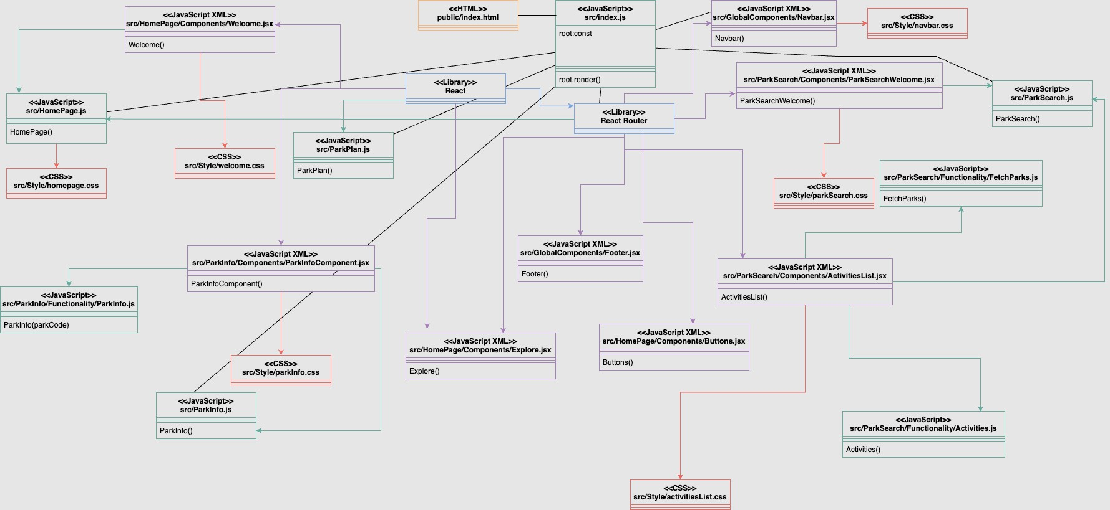

The class diagram above provides a view of the relationships between the key components in the *Exploring National Parks* website. The class diagram reflects the website’s user interface through a collection of components, created using JavaScript XML files. These components, including ParkInfoComponent, NavBar, Footer, Buttons, Explore, Welcome, ParkSearchWelcome, and ActivitiesList, are each associated with specific functionalities.

Moving beyond the user interface, the class diagram also represents the functional components responsible for implementing the website’s logic. These components, HomePage.js, ParkInfo.js, ParkPlan.js, ParkSearch.js, Index.js, Activities.js, and FetchParks.js, are linked to their corresponding user interface components.

In addition to the user interface and functionality components, the class diagram incorporates styling files, such as HomePage.css, NavBar.css, ParkInfo.css, ParkSearch.css, Welcome.css, and ActivitiesList.css. These styling files are associated with their respective user interface components. Keeping the styling separate from the user interface and functionality components allows for easy modification of the appearance without cluttering or impacting the logic.

As for the specifics of each file, Index.js serves as the entry point for the web application, which utilizes the javascript library, React. Index includes the setup for the website and imports the components that make up the user interface. Homepage.js holds the code for the main landing page of the website. ParkInfo.js holds the logic for displaying detailed park information through an API call to the National Parks Services ‘parks’ API.

ParkInfoComponent.jsx, a React component, renders the detailed information to the user interface. ParkPlan.js, while not fully implemented during this sprint, is intended for creating detailed plans after a user selects a park. ParkSearch.js is dedicated to handling searching functionality, allowing users to input preferred activities and receive a list of matching parks.

ParkSearchWelcome.jsx, a react component, renders a welcome message and short description on the park search page. Activities.js handles the logic associated with fetching the list of available activities, through a call to the National Parks Services 'activities’ API. ActivitiesList.jsx, a react component, is responsible for rendering the list of activities a user can choose from when searching for parks. FetchParks.js handles the logic related to fetching parks for ParkSearch. Footer.jsx, NavBar.jsx, Buttons.jsx are responsible for rending the footer, navigation bar, and the homepage buttons to either go to park search or plan a trip, based on a selected park. Welcome.jsx and Explore.jsx are responsible for rendering welcome information for the user on the homepage.

## Sequence Diagram

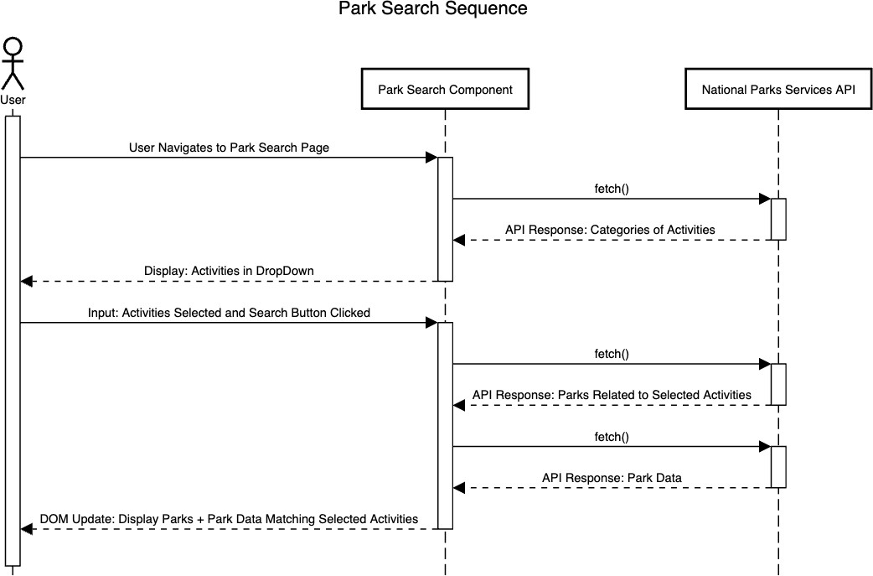

Figure S.1

Figure S.1: The Park Search Sequence Diagram above illustrates the interactions between a user, the park search component, and the National Parks Service’s API. The diagram begins with the actor/user navigating to the park search page on the website, which activates/renders the park search component. The component then initiates a call to the National Parks Service’s API by calling the fetch() method, resulting in the activation of the API. The API responds with all the categories of activities, which are then displayed to the user in a dropdown menu by the park search component.

From here, the user is able to provide input by selecting activities and clicking a search button. The park search component is activated and makes two calls to the NPS API, the first fetching all parks related to the selected activities, and then second fetching the park data for each park returned. The API responds with park data and the park search component updates the DOM to display the parks and their data matching the user’s selected activities. (The UML website does not have an option to show an asynchronous call with the arrowhead, but all three fetch() calls are asynchronous)

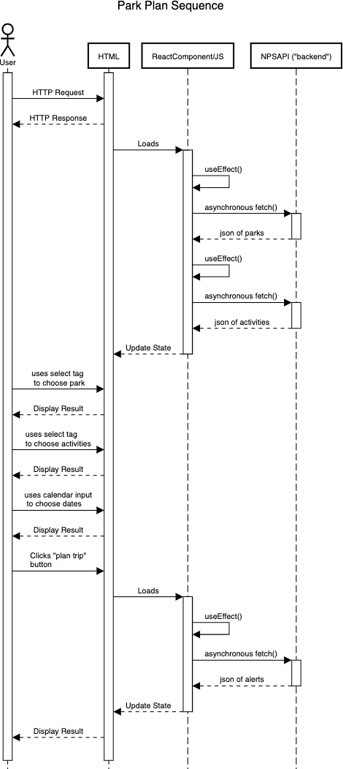 Figure S.2

Figure S.2: This sequence diagram represents a user interacting with the website and how the website interacts with its frontend components and connecting with the related API. The user navigating to the page calls an HTTP request to the server that hosts the HTML page and gets a response. The HTML page begins to render by loading the graphic related components from

React. React then calls its javascript rendering function useEffect to make asynchronous calls to the NPS API which returns the relevant JSONs from the fetch. Since it is asynchronous, React updates the HTML for the user. Now that the HTML is updated to display the relevant graphics, the user interacts with them and the HTML updates the display to represent their actions. The user can also click a button that will reactivate React to make another fetch call to the API and return the JSON of alerts, update the HTML, and update the display for the user. (The UML website does not have an option to show an asynchronous call with the arrowhead, so it is denoted as asynchronous)

## Project Progress Week 2 Progress

**Sprint Goal:**The goal of this sprint was to modify the website to include a homepage and a search page, where users can find national parks based on the activities they’d like to do while there.

**Sprint Problems:**Although many tasks were completed, there were some that were incomplete. Though these tasks were mostly of a larger size. One of the biggest hurdles was with the “Park Search - Use output of search bar to return park list” task. This became a problem as after trying to develop the code, we found that the API endpoint did not output the data that we had expected it to. Due to this, lots of time was spent trying to debug and understand the API and led to a delay in the completion of this task. Having other tasks that are not started or that are in progress is due to potentially having more tasks in the sprint than time allowed for each developer, or being blocked by requiring a task that was also not completed in order to continue your task.

### Backlog Features focused on in this Sprint

* Homepage with information about the site
* Homepage button to navigate to park search page
* Homepage button to navigate to park planning page
* Park search page with information, detailing the purpose of the page
* Selecting park activities with a search bar for park search
* Selecting park activities with a drop down for park
* Selecting park activities shows activities in the search bar for park search
* Viewing selected park activity tags in search bar
* Clicking the search button to see park options matching park activities selected
* Park info page with longer description of a speciﬁc park

|  |  |  |
| --- | --- | --- |
| **Tasks in Sprint** | **Task Status at end of Sprint** | **Assigned To** |
| **Homepage - Make landing page** | Done | Daniel |

|  |  |  |
| --- | --- | --- |
| **Homepage-Creating routing/page for park planning** | Done | Daniel |
| **Homepage - Create routing/page for park search** | Done | Daniel |
| **Homepage - Add main structure** | Done | Sarina |
| **Homepage - Connect button to park search** | Done | Sarina |
| **Homepage - Connect button to park planning** | Done | Sarina |
| **Homepage - Make top menu bar** | Done | Sarina |
| **Homepage - Make footer** | Done | Jason |
| **Homepage - Overall page styling mockup** | Done | Daniel |
| **Park Search - Park List Styling** | In Progress | Daniel |
| **Park Search - Search bar for activities** | Done | Erin |
| **Park Search - Search button to signal done selecting activities** | Done | Erin |
| **Park Search - Use output of search bar to return park list** | In Progress | Erin |
| **Park Search - Overall page styling mockup** | In Progress | Sarina |
| **Park Search - About section** | Done | Jason |
| **Park Search - Background Page Styling** | Done | Jason |
| **Park Search - Click on returned park, get short description** | Not Started | Jason |
| **Park Search - Button within short description** | Not Started | Jason |

|  |  |  |
| --- | --- | --- |
| **reroutes for park with more info** |  |  |
| **Park Info - Retrieve park website** | Done (pulled into sprint) | Jason |
| **Park Info - Retrieve basic park info** | Done | Jason |
| **Park Info - Retrieve photos for park** | Done (pulled into sprint) | Jason |
| **Park Planning - Overall Page Styling Mockup** | Done | Erin |

### Calculations for Sprint Velocity

Github projects do not use a built-in story point method to keep track of task size on the project board, instead relying on a pseudo-“t-shirt” size system with labels that include “Tiny”, “Small”, “Medium”, “Large”, and “Extra Large”.

For our purposes, the following conversion was used to transfer from the Github projects’ sizing method to a more traditional story point approach (ex. 1, 3, 5, 8, and 11):

**Tiny** → **1** story points **Small** → **3** story points **Medium** → **5** story points **Large** → **8** story points

**Extra Large** → **13** story points

|  |  |
| --- | --- |
| **Estimated Velocity**  (At beginning of Sprint) | 106 |
| **Calculated Velocity**  (At end of Sprint) | 74 |

## Week 3 Progress (OFF WEEK- SPRINT WAS COMBINED WITH WEEK 4)

**Sprint Goal:** SEE WEEK 4

**Backlog Features** SEE WEEK 4

|  |  |  |  |
| --- | --- | --- | --- |
| **Tasks in Sprint** | **Size** | **Task Status at end of Sprint** | **Assigned To** |
|  |  |  |  |
|  |  |  |  |
|  |  |  |  |
|  |  |  |  |
|  |  |  |  |

|  |  |
| --- | --- |
| **Estimated Velocity**  (At beginning of Sprint) | 0 |
| **Calculated Velocity**  (At end of Sprint) | 0 |

## Week 4 Progress

**Sprint Goal:** The goal of this sprint was to complete the park search page (where users can find national parks based on the activities they’d like to do while there), connect the park search page to the park info page (so users can navigate to a page with more information on a specific park from the curated list returned from their selected activities), and to begin the park planning page (where users will be able to enter their desired activities, a desired park, and a timeframe to generate a individualized park visit schedule).

### Backlog Features

* Clicking the search button to see park options matching park activities selected
* Clicking one of the parks that populates from the activity search gives a short description of the park
* Clicking on a “More Information” button within the shorter park description navigates to a page with a longer park description
* Selecting park from search bar
* Selecting park from dropdown
* Selecting park visit date from calendar
* Selecting park visit date from search/input bar
* Selecting park activities from dropdown for park planning
* Selecting park activities from search bar for park planning
* Selecting park activities shows activities in the search bar for park planning
* Clicking on the “Generate Schedule” button populates a schedule ﬁtting with the selected park, activities, and days
* Park info page with longer description of a speciﬁc park

|  |  |  |  |
| --- | --- | --- | --- |
| **Tasks in Sprint** | **Size** | **Task Status at end of Sprint** | **Assigned To** |
| **Park Info - Retrieve video to imbed** | Medium (5) | Completed | Sarina |
| **Park Planning - Use dates from calendar to set up schedule structure (with morning, afternoon, evening)** | Large (8) | Completed | Daniel |
| **Park Planning - Search bar for activities with input and dropdown (for search)** | Medium (5) | Completed | Sarina |
| **Park Planning - Report relevant park closures/alerts** | Medium (5) | Completed | Daniel |

|  |  |  |  |
| --- | --- | --- | --- |
| **Park Planning - Search bar for park with input and dropdown (for search)** | Medium (5) | Completed | Daniel |
| **Park Search - Overall page styling mockup** | Large (8) | Completed | Sarina |
| **Park Search - Click on returned park, get short description (for Park info)** | Medium (5) | Completed | Jason |
| **Park Search - Button within short description reroutes to page for park with more info (for Park Info)** | Small (3) | In Progress | Jason |
| **Park Search Fix Footer so that it doesn’t overlap other components** | Tiny (1) | Completed  (pulled in part way through sprint) | Jason |
| **Park Planning - Create search button that indicates to use the results from activities, park, and date selection** | Medium (5) | Completed | Erin |
| **Park Search - Use output of search bar to return park list** | Large (8) | Completed | Erin |
| **Park Search - Park list styling** | Large (8) | Completed | Erin |
| **Park Planning - Go through activity list and define what is done indoors/outdoors, what can be done in cold/warm weather, etc. (investigation task)** | Large (8) | Completed | Sarina |
| **Park Info - Overall styling mockup (in Figma)** | Large (8) | Completed | Jason |
| **Park Planning - Define logic for park scheduling (investigation task)** | Large (8) | Completed | Erin |
| **Park info - Retrieve park visitation info (hours, fee, activities list)** | Medium (5) | Completed | Jason |

|  |  |  |  |
| --- | --- | --- | --- |
| **Documentation - List out sprint goal, sprint tasks, and sprint velocity** | Small (3) | Completed | Erin |
| **Documentation - First UML Sequence Diagram** | Medium (5) | Completed | Sarina |
| **Documentation - Second UML Sequence Diagram** | Medium (5) | Completed | Daniel |
| **Park Planning - Alerts styling** | Medium (5) | Completed | Daniel |
| **Park Planning - Date selection feature and return date (for search)** | Medium (5) | Completed | Daniel |
|  |  |  |  |

### Calculations for Sprint Velocity

Github projects do not use a built-in story point method to keep track of task size on the project board, instead relying on a pseudo-“t-shirt” size system with labels that include “Tiny”, “Small”, “Medium”, “Large”, and “Extra Large”.

For our purposes, the following conversion was used to transfer from the Github projects’ sizing method to a more traditional story point approach (ex. 1, 3, 5, 8, and 11):

**Tiny** → **1** story points **Small** → **3** story points **Medium** → **5** story points **Large** → **8** story points

**Extra Large** → **13** story points

|  |  |
| --- | --- |
| **Estimated Velocity**  (At beginning of Sprint) | 117 |
| **Calculated Velocity**  (At end of Sprint) | 114 |

## Week 5 Progress

**Sprint Goal:** The goal of this sprint was to complete the park planning page (where users will be able to enter their desired activities, a desired park, and a timeframe to generate an individualized park visit schedule), to complete the park info page (all functionality and styling), to add a “featured parks” list on the homepage of the application, and to complete general bug fixes and improvements.

### Backlog (User) Features for this sprint

* Homepage with information about the site
* Clicking the search button to see park options matching park activities selected
* Clicking on the “Generate Schedule” button populates a schedule ﬁtting with the selected park, activities, and days
* Park info page with longer description of a speciﬁc park

### Complete List of Backlog (User) Features

* Homepage with information about the site
* Homepage button to navigate to park search page
* Homepage button to navigate to park planning page
* Park search page with information, detailing the purpose of the page
* Selecting park activities with a search bar for park search
* Selecting park activities with a drop down for park search
* Selecting park activities shows activities in the search bar for park search
* Viewing selected park activity tags in search bar
* Clicking the search button to see park options matching park activities selected
* Clicking one of the parks that populates from the activity search gives a short description of the park
* Clicking on a “More Information” button within the shorter park description navigates to a page with a longer park description
* Clicking on a “Make Schedule” button within the longer park descriptions navigates to the planning page for that park
* Park planning page with information, detailing the purpose of the page
* Selecting park from search bar
* Selecting park from dropdown
* Selecting park visit date from calendar
* Selecting park visit date from search/input bar
* Selecting park activities from dropdown for park planning
* Selecting park activities from search bar for park planning
* Selecting park activities shows activities in the search bar for park planning
* Clicking on the “Generate Schedule” button populates a schedule ﬁtting with the selected park, activities, and days
* Park info page with longer description of a speciﬁc park

|  |  |  |  |
| --- | --- | --- | --- |
| **Tasks in Sprint** | **Size** | **Task Status**  **at end of Sprint** | **Assigned To** |
| **Park Search - Button within short description reroutes to page for park with more info (for Park Info)** | Small (3) | Completed | Jason |
| **Homepage - Create “Highlighted Parks” section** | Large (8) | Completed | Sarina |
| **General - Create Favicon for site** | Small (3) | Completed | Jason |
| **Park Info - Styling for basic park info** | Medium (5) | Completed | Jason |
| **General - Fix Refresh Issue** | Medium (5) | Completed | Erin |
| **Miscellaneous Clean up** | Large (8) | Completed | Daniel |
| **Park Planning - Call to NWS API to return weather for given location/time** | Large (8) | Completed | Daniel |
| **Park Planning - Fill in schedule with activities based on search logic** | Large (8) | Completed | Erin |
| **General - API Load Issues** | Medium (5) | Completed | Daniel |
| **Park Planning - Report weather alerts for given days if available** | Medium (5) | Completed | Daniel |
| **Park Planning - Schedule Styling** | Large (8) | Completed | Erin |
| **Park Info - Fix Zero applicable parks from return all parks** | Small (3) | Completed | Sarina |
| **Park Info - Create button to make schedule for selected park (for Park Planning)** | Tiny (1) | Completed | Jason |
| **Park Info - List pages to have all Parks** | Medium (5) | Completed | Jason |

|  |  |  |  |
| --- | --- | --- | --- |
| **Park info - Styling for park visitation information and website** | Medium (5) | Completed | Jason |
| **Park Info - Styling for park media (videos and pictures)** | Large (8) | Completed | Jason |
| **Park Info - Connect button for schedule to Park Planning page (for Park Planning)** | Small (3) | Completed | Jason |
| **Fix issues with GitHub pages/Explore other hosting options** | Large (8) | Completed | Erin |
| **Replace Footer** | Tiny(1) | Completed | Daniel |
| **Save API calls to a cache** | Medium (5) | Completed | Daniel |
| **Park Search - Add state selection capability (or distance away)** | Medium (5) | Completed | Sarina |
| **General - Refactor API Calls** | Small (3) | Completed | Daniel |
| **General - Miscellaneous Clean up** | Medium (5) | Completed | Erin |
| **Create JSDoc** | Large (8) | Completed | Daniel |
| **Individual Part of Presentation** | Large x4 (8) | Completed | Daniel, Sarina, Jason, Erin |

### Calculations for Sprint Velocity

Github projects do not use a built-in story point method to keep track of task size on the project board, instead relying on a pseudo-“t-shirt” size system with labels that include “Tiny”, “Small”, “Medium”, “Large”, and “Extra Large”.

For our purposes, the following conversion was used to transfer from the Github projects’ sizing method to a more traditional story point approach (ex. 1, 3, 5, 8, and 11):

**Tiny** → **1** story points **Small** → **3** story points **Medium** → **5** story points **Large** → **8** story points

**Extra Large** → **13** story points

|  |  |
| --- | --- |
| **Estimated Velocity**  (At beginning of Sprint) | 158 |
| **Calculated Velocity**  (At end of Sprint) | 158 |

### Complete List of Backlog Features

* Park Search - Button within short description reroutes to page for park with more info (for Park Info)
* Homepage - Create “Highlighted Parks” section
* General - Create Favicon for site
* Park Info - Styling for basic park info
* General - Fix Refresh Issue
* Miscellaneous Clean up
* Park Planning - Call to NWS API to return weather for given location/time
* Park Planning - Fill in schedule with activities based on search logic
* General - API Load Issues
* Park Planning - Report weather alerts for given days if available
* Park Planning - Schedule Styling
* Park Info - Fix Zero applicable parks from return all parks
* Park Info - Create button to make schedule for selected park (for Park Planning)
* Park Info - List pages to have all Parks
* Park info - Styling for park visitation information and website
* Park Info - Styling for park media (videos and pictures)
* Park Info - Connect button for schedule to Park Planning page (for Park Planning)
* Fix issues with GitHub pages/Explore other hosting options
* Replace Footer
* Save API calls to a cache
* Park Search - Add state selection capability (or distance away)
* General - Refactor API Calls
* General - Miscellaneous Clean up
* Create JSDoc
* Individual Part of Presentation